**Ex No:1 UID-3 Date:25.01.2025**

**Lab-1: Figma**

**Bad Design VS Good Design**

**Bad Design**

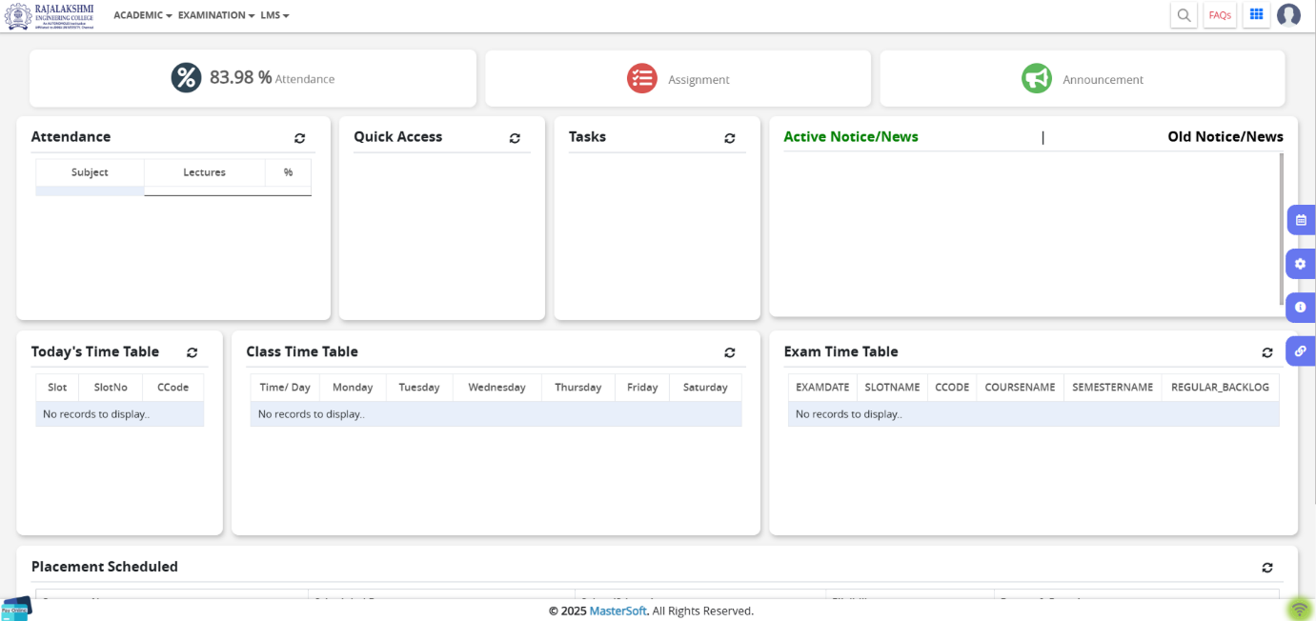

* **No Clear Focus** on Important things like attendance, timetable
* **Not Enough Space** as there’s very little space between sections, making everything look messy.
* **Hard to Read** – The text is small and not very clear
* **Buttons Are Not Noticeable**
* **Lack of Visual Appeal** as the design looks outdated and dull, failing to attract users.

**I have taken Rec Erp portal because they are used frequently by students, so making them simple and easy to use will improve accessibility and attract more users. This current design looks too complicated and not visually appealing. The icons and text are small and unclear, which can create a bad user experience. Making the layout simpler, increasing the size of icons, and using a cleaner design will make it more user-friendly and efficient, ensuring students can navigate it easily without confusion.**

**Good Design**

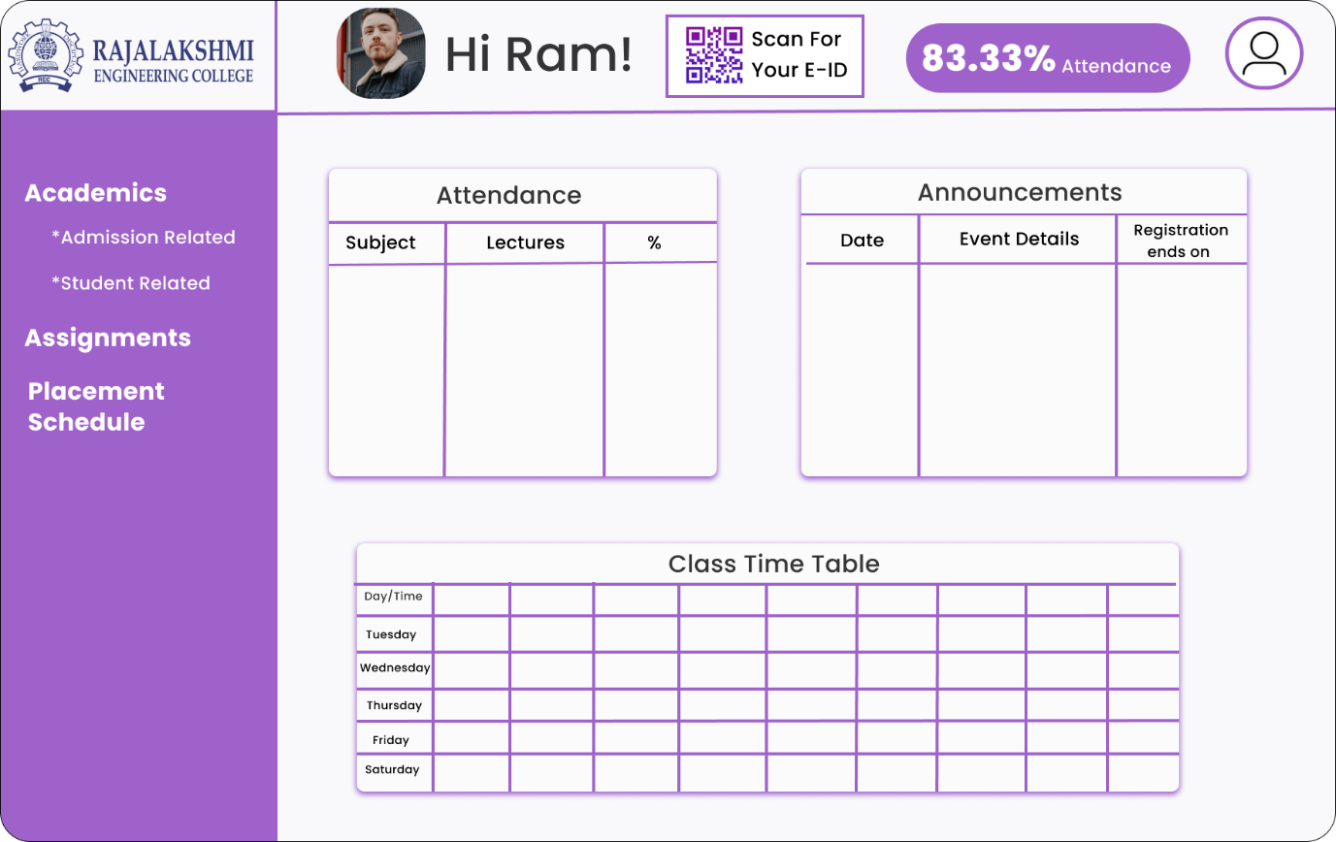

* **Well-Organized Layout as the sections are neatly arranged, making it easy for users to find important information**
* **Easy Navigation – The sidebar menu clearly categorizes options like Academics, Assignments, and Placement Schedule**
* **Added Functionality – Features like the QR code for E-ID scanning and an Announcements section enhance user convenience.**
* **Improved Readability – Good spacing, clear headings, and a structured timetable layout make the content easy to understand**

**After ensuring all icons are clear and easy to recognize, the user experience will be greatly improved. The structured layout and proper spacing make navigation effortless. The use of soft and balanced colors enhances the visual appeal, making the design more engaging and user-friendly.**